**MM 226 Supervised Learning project consent form**

**PART II _ Submission**

**Name of project supervisor(s)**: Prof. Prasanna Kumar S. Mural

**Title of project:** AI-driven Smart Gloves for Motion Detection

**Project participant details: (Max 5 participants)**

| **Roll Number** | **Name of Student** | **Role of participant in project** |
| --- | --- | --- |
| 21D110016 | M. Hassan Shaikh | Project Lead & AI Researcher |
| 21D110012 | Om Kulpe | Prototype Engineer & Software Developer |
| 21D110007 | Keloth Uday Krishna | Documenter & Prototype Engineer |
| 210110054 | Jai priyadarshi | AI Researcher & Experimentation |
| 210110038 | Dev Kumar acharya | Experimentation & Software Developer |

**Objectives of the project: the deliverables of the project must be clearly outlined.**

Develop smart gloves equipped with piezoelectric and triboelectric sensors to detect hand motion & gestures for sign language recognition

1. Designing & 3D printing Polyvinylidene fluoride polymer based triboelectric highly shape adaptive sensor for sensitive joint motion monitoring & tactile sensing, demonstrating it’s application in real-time human-machine interaction

2. Utilizing an Arduino micro-controller to develop a custom sketch program file that interface with a piezoelectric/triboelectric 3D printed sensor, enabling precise real-time signal recording, advanced processing and data logging for motion detection

3. Pre-Processing the signal using advanced Signal Processing techniques, apply moving window mechanism to construct input matrix and implement LSTM/Transformer/RNNs/ other hybrid models to achieve a proposed accuracy.

**Role of each member:**

We have decided the roles on basis of what individual wants to learn and hence allotted multiple roles(so it follows as primary & secondary roles).

Responsibility of each roles are as follows:

**Project Lead**

* Communicating with the project supervisor and TA regarding the status of the project
* Arranging lab visits for experimentation and resolving queries
* Arranging materials required for the project and budget management

**Documenter**

* Documenting the contents discussed in meetings for future reference
* Creating reports and presentations involved in the project

**Prototype Engineer**

* Assembling all components to build prototypes of the gloves
* Overlooking integration of the software and hardware involved

**Experimentation**

* Mechanical testing and structural analysis of materials used
* Electrical testing of microcontroller (Arduino)
* Establishing connection between the software and the electrical components

**AI Researcher**

* Researching about efficient techniques for motion detection
* Building and testing different AI models

**Software Developer**

* Building a program to detect and analyse signals coming from the glove
* Applying AI models to classify hand gestures

**Timeline of the project (in the format given below)**

| Month | Week | Assigned task |
| --- | --- | --- |
| August | I | 1. Brainstorming ideas 2. Setting objectives 3. Finalising project details |
| II |
| III | 1. Processing polymer to generate filament 2. 3D printing components 3. Mechanical testing and structural analysis |
| IV |
| September | I | Integration of all physical components of the smart glove |
| II |
| III | **MIDSEM** |
| IV |
| October | I | 1. Software development and AI model building 2. Connecting software to hardware 3. Testing and modifying |
| II |
| III |
| IV |
| November | I | Ideating and planning the usage of this technology in other domains |
| II |
| III | **ENDSEM** |
| IV |

**Mid- semester progress**

**1] Key achievements thus far**

Mode Selection:

* Explored two sensing modes: contact-separation and linear-sliding.
* Choose linear-sliding mode for voltage generation based on triboelectric motion detection.

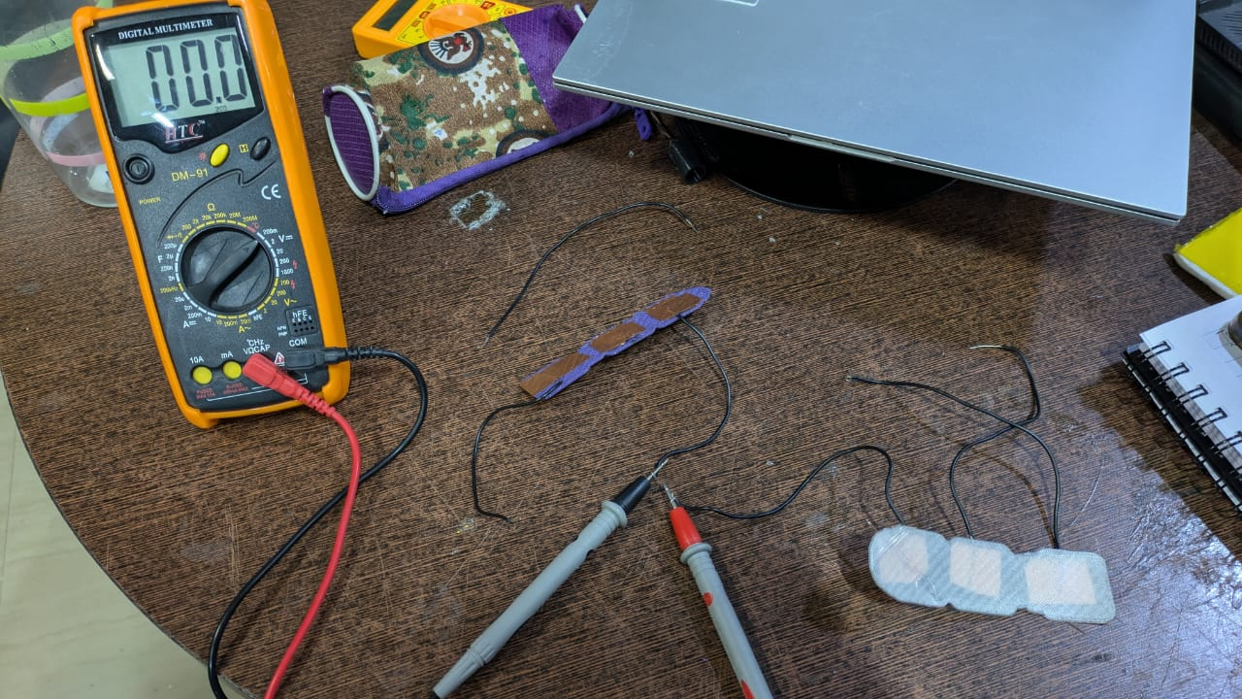

A setup to test triboelectric sensor with multilayer sliding configuration

Material Selection:

* Evaluated different materials for triboelectric sensors, settling on PVDF, PLA, nylon and ABS.

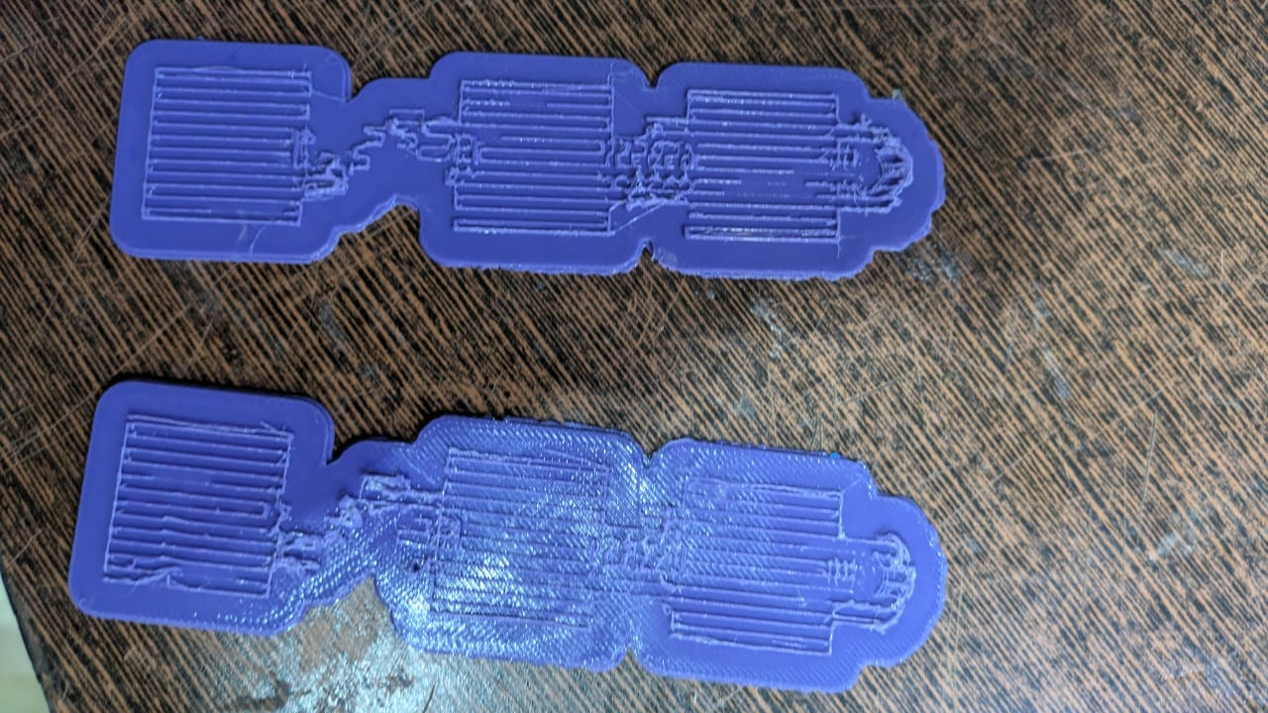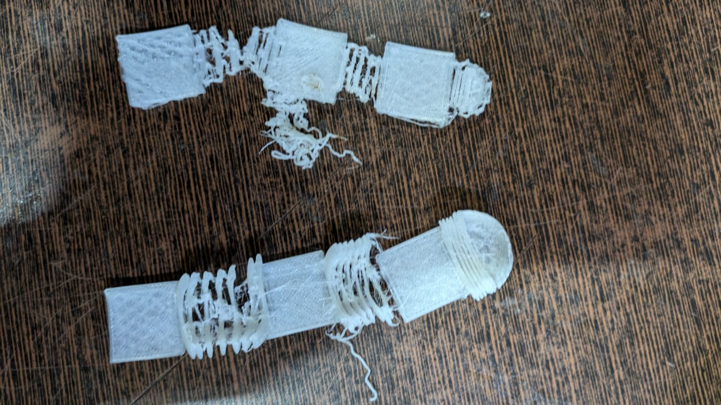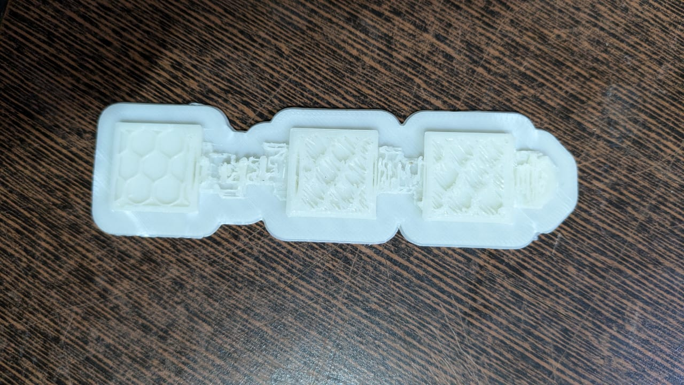

3D printed PLA strips 3D printed Nylon strips 3D printed ABS strips

Sensor Structure Design:

* Finalized the structural design of the triboelectric sensors through team discussions.
* Created 3D models of the sensor structures using Blender software for precise fabrication.
* Designed a multi-layer structure to accompany the triboelectric behavior according to linear sliding configuration.

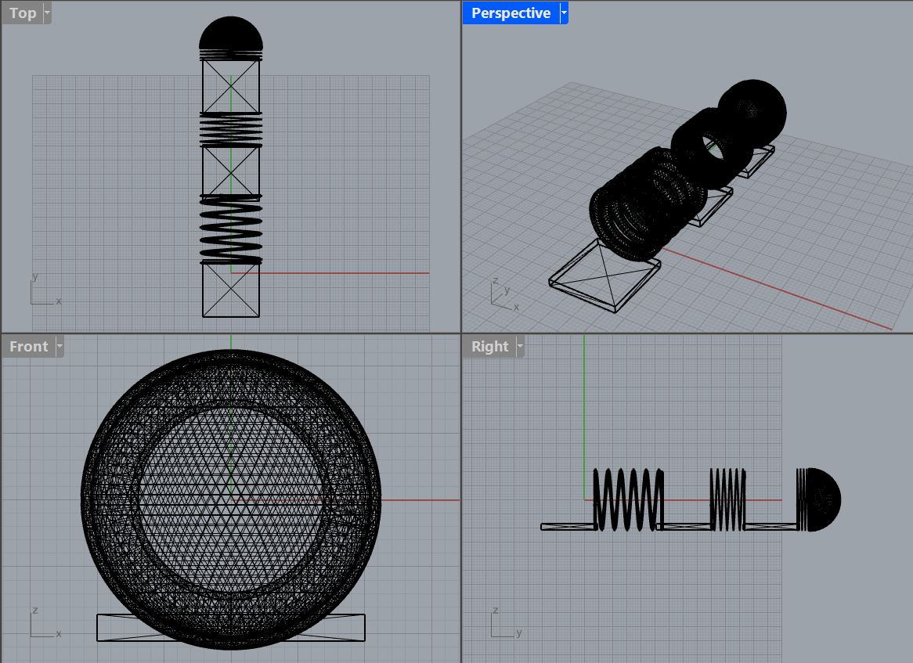

3D Printing of Sensors:

* Produced PVDF filaments in the polymer processing lab for sensor fabrication.
* Utilized Flashforge Guider IIs 3D printer to print multiple polymer strips(as discussed above) for testing the triboelectric effect.

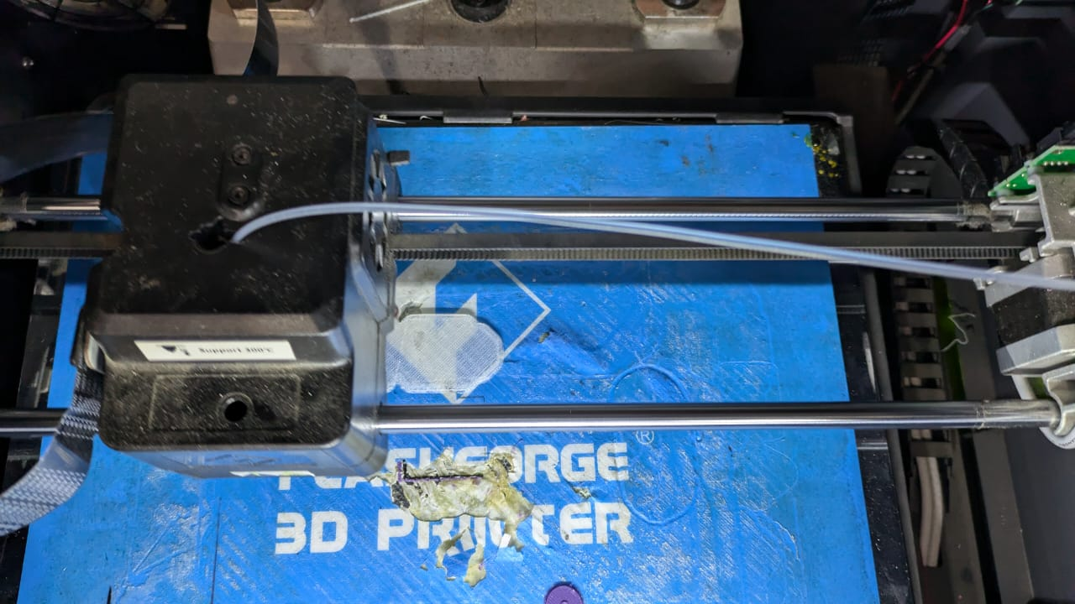

Component Procurement:

* Ordered essential electronics components, including Arduino microcontrollers, breadboards, and nylon gloves via Amazon.
* Purchased additional components (copper tape, resistors, lead wires, USB cable, multimeter) from local electronics stores.

Sensor Assembly:

* Attached copper electrodes to the sensors using copper tape for effective signal conduction.
* Connected sensors to the multimeter using lead wires for voltage measurement.

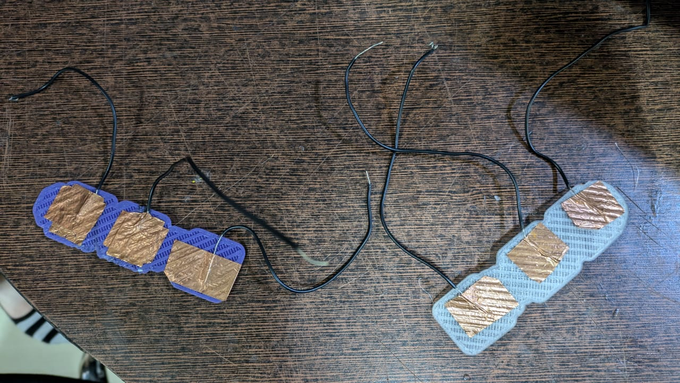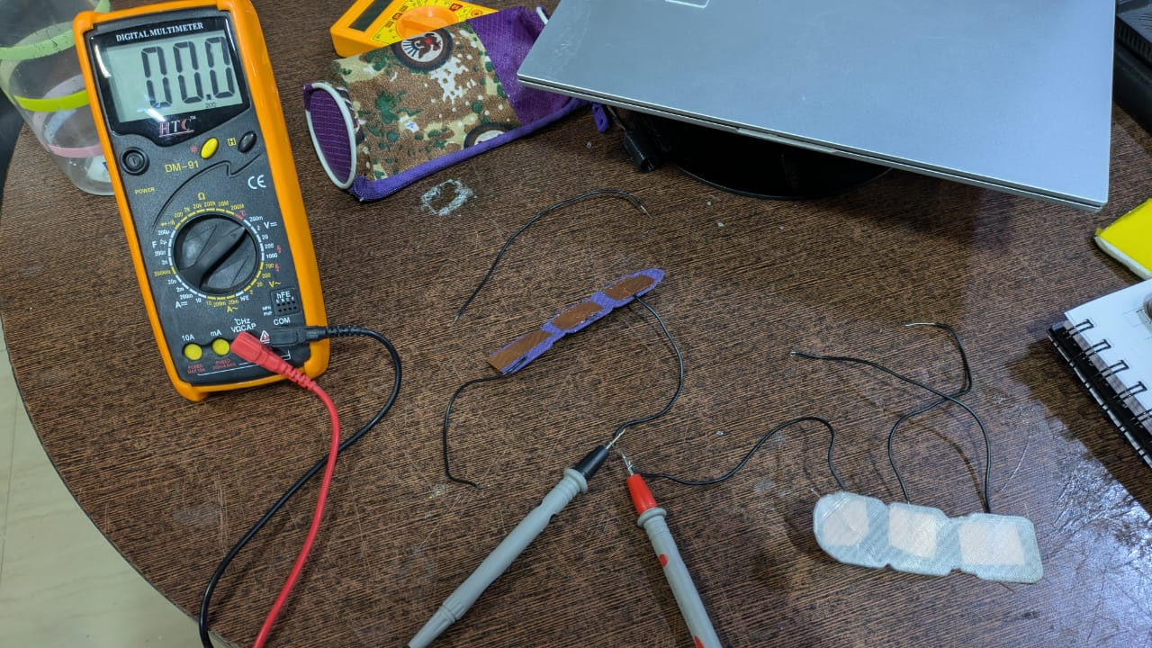

Testing and Measurement:

* Tested the sensors by rubbing positive triboelectric materials (nylon) over negative triboelectric materials (PLA, ABS).
* Achieved measurable voltage outputs in the range of 2.0x200-4.0x200 mV, indicating successful triboelectric charge generation.

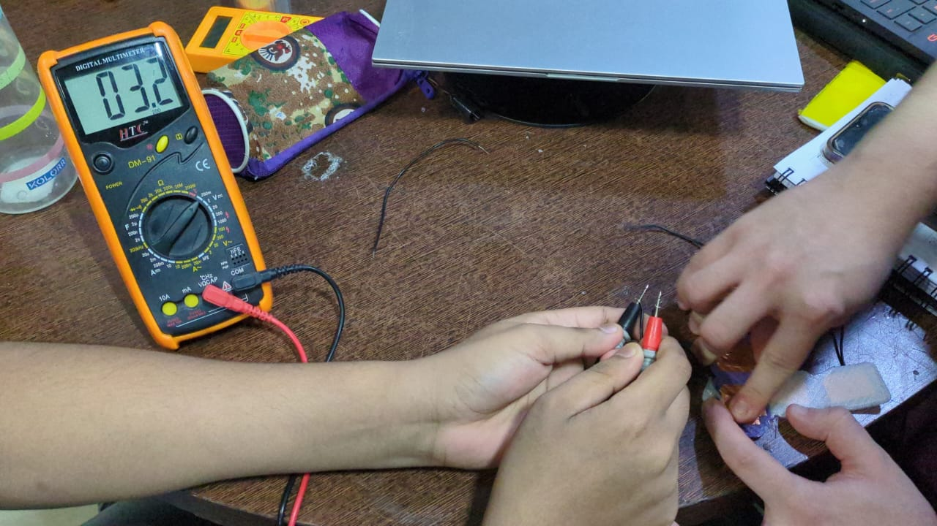

**2] Challenges faced and solved**

PVDF Filament Moisture capture

* During 3D printing, the PVDF filament exhibited a blackish color due to moisture exposure.
* To address this, we planned to remade the filament and implemented a storage solution using moisture-free containers with silica gel.

Nylon Sensor Printing Issues

* Initial attempts to 3D print nylon sensors were unsuccessful due to material compatibility issues with the printer.
* Through experimentation, we determined the optimal printing temperature to be 230°C, slightly above nylon's melting point (220°C), resolving structural inconsistencies that arose at lower (230°C) and higher (250°C) temperatures.

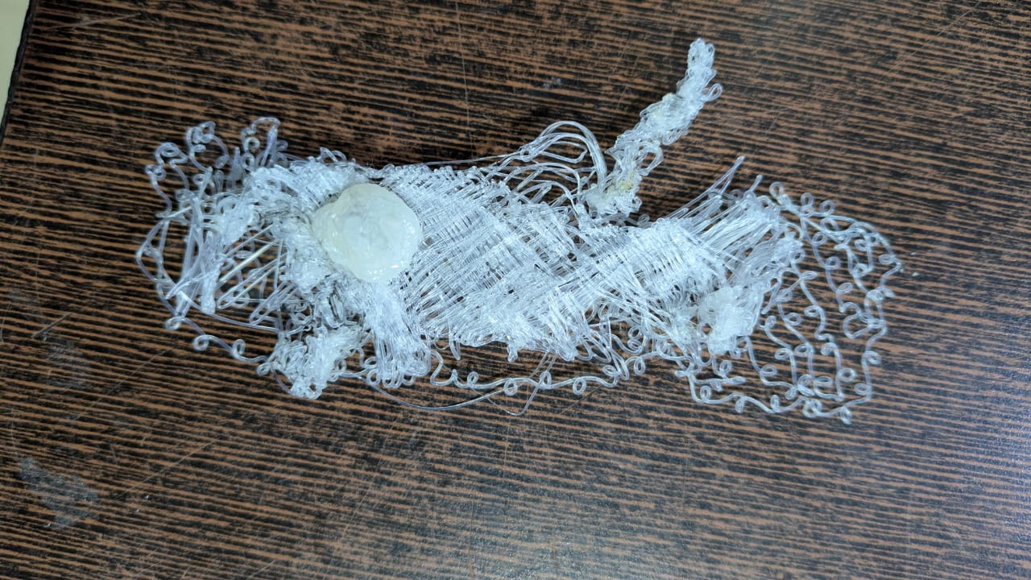

at 230°C at 250°C(over melt)

Sensor Structure Design

* We tested three designs for the sensor: (a) long rectangular strips, (b) rectangular strips joined with zig-zag springs, and (c) rectangular strips joined with solenoid-shaped springs.
* The first design lacked aesthetics, and the second was difficult to assemble due to the need for additional materials.
* We chose the third solenoid design for its simplicity and structural viability.

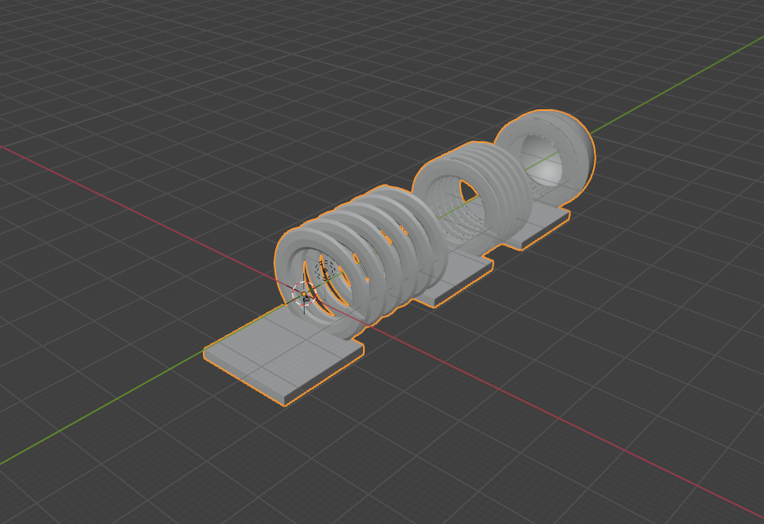

Sensor Attachment Method

* Initially, we used double-sided tape to attach sensors to the glove, but it added unnecessary insulation.
* We switched to wrapping Kapton tape around the sensor and glove fingers, providing a more suitable attachment method without compromising performance.
* We are yet to assemble this but have tested without it.

Triboelectric Sensing Model

* We compared two sensing modes: contact separation and linear sliding.
* Contact separation required complex mechanical assembly, so we opted for the linear sliding mode, which offered a simpler and more feasible implementation.

**3] If any changes in the project, then clearly mention the new objectives.**

There are no changes in the project. We have already achieved one of our objectives, that is,

* *Designing & 3D printing Polyvinylidene fluoride polymer based triboelectric highly shape adaptive sensor for sensitive joint motion monitoring & tactile sensing, demonstrating it’s application in real-time human-machine interaction*

The remaining objectives are

* *Utilizing an Arduino micro-controller to develop a custom sketch program file that interface with a piezoelectric/triboelectric 3D printed sensor, enabling precise real-time signal recording, advanced processing and data logging for motion detection*
* *Pre-Processing the signal using advanced Signal Processing techniques, apply moving window mechanism to construct input matrix and implement LSTM/Transformer/RNNs/ other hybrid models to achieve a proposed accuracy*

**Timeline – Part II Submission**

The parts highlighted in green have been completed. We are right on track as per our initial timeline.

| Month | Week | Assigned task |
| --- | --- | --- |
| August | I | Brainstorming ideas  Setting objectives  Finalising project details |
| II |
| III | Processing polymer to generate filament  3D printing components  Mechanical testing and structural analysis |
| IV |
| September | I | Integration of all physical components of the smart glove(sensor assemble) |
| II |
| III | **MIDSEM** |
| IV |
| October | I | Software development and AI model building  Connecting software to hardware  Testing and modifying |
| II |
| III |
| IV |
| November | I | Ideating and planning the usage of this technology in other domains |
| II |
| III | **ENDSEM** |
|  |

**Final submission**

1. **Key achievements**

**( In bullet points. Please map the objectives and the achievements to clarify the level of success achieved)**

* Using piezoelectric sensors integrated with Arduino, we effectively quantified finger motion, capturing real-time, measurable data to support detailed analysis and processing.
* We developed a mechanism that offers the option of a 3D-printed ring for enhanced stability or a ring-free setup for increased flexibility. The ring provides consistent sensor readings, while the ring-free design supports applications requiring greater adaptability
* Using Arduino, we captured time-sequential data of finger movements at fixed intervals, accurately reflecting the timing and dynamics of motion. To enhance training efficiency, we incorporated synthetic data alongside real-world data, allowing for rapid model training and validation across various movement patterns. Leveraging AI models, particularly Long Short-Term Memory (LSTM) networks and Self-Supervised Learning (SSL) approach, we effectively distinguished individual finger motions, resulting in improved accuracy and responsiveness in motion pattern recognition.

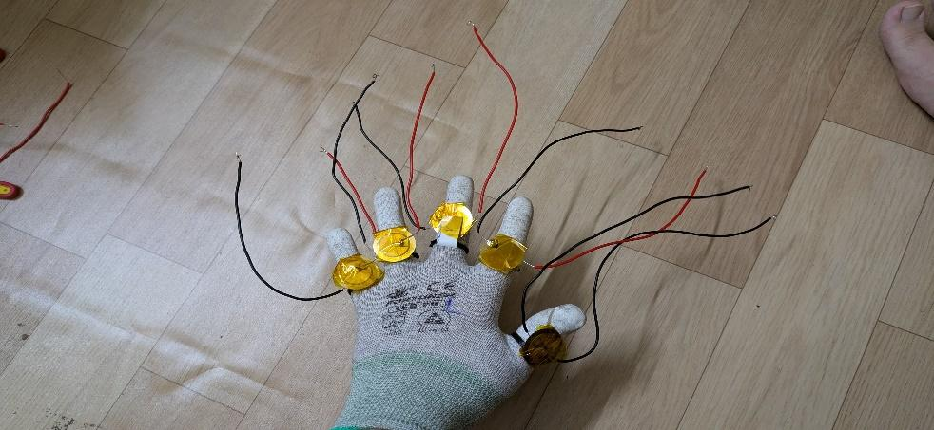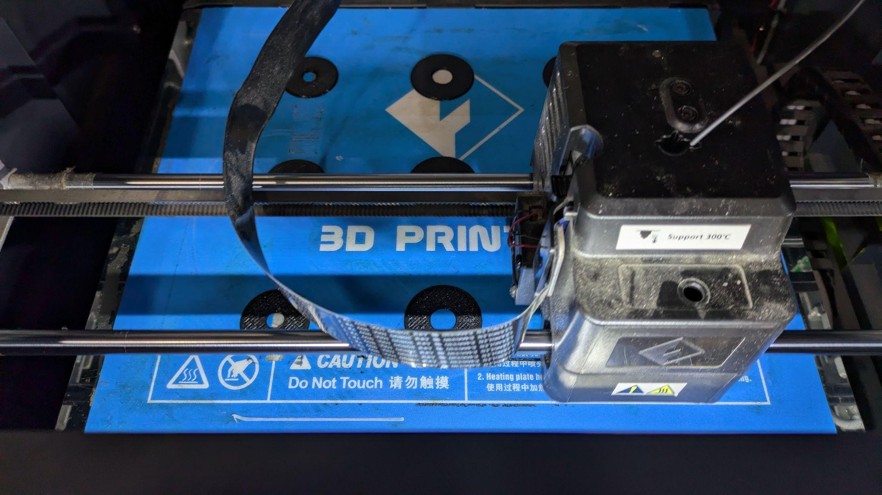

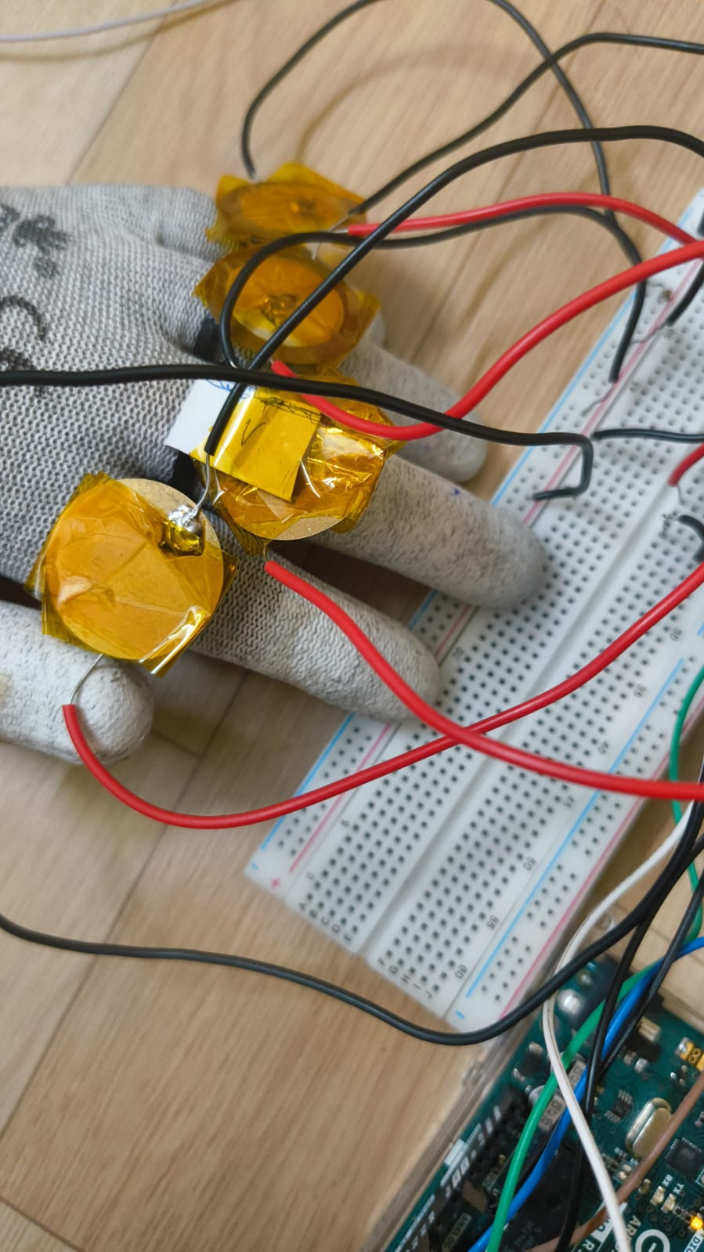

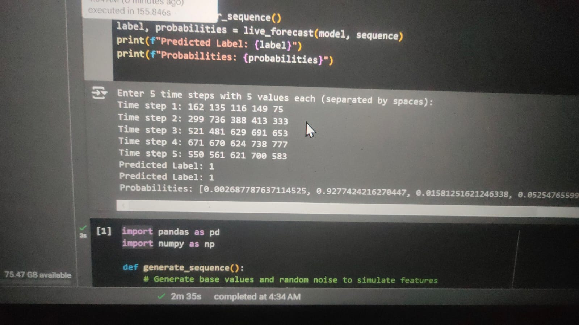

**Fig1: 3D printing of rings**

**Fig2: Piezoelectric sensor setup on glove**

**Fig3: Breadboard and Arduino setup**

**Fig4: Prediction labels using AI model (0 = Thumb, 1 = Index, 2 = Middle, etc.)**

**Demo link:** [**https://shorturl.at/veept**](https://shorturl.at/veept)

1. **Major challenges faced ( highlight the unexpected issues)**

* **Unstable Data from Random Sensor Values**Sensor readings were inconsistent, often producing random values that hindered reliable quantification. This variability necessitated additional filtering and calibration to ensure usable data.
* **Low Voltage Levels Limiting Measurement Precision**The sensors generated signals in the microvolt range, which were detectable with a Digital Multimeter (DMM) but difficult to quantify accurately on the Arduino due to its limited precision (up to 10-2 V). This constraint affected the system's ability to capture subtle motion variations critical for accuracy.
* **Arduino Precision Limitations and Raspberry Pi as a Solution**The Arduino’s resolution was insufficient for microvolt-level measurements, prompting consideration of the Raspberry Pi or ESP 32 microcontroller. With higher precision, the they could better support the fine measurements essential for the project.
* **Choosing Between Piezoelectric and Triboelectric Sensors**Selecting the optimal sensing mechanism between piezoelectric and triboelectric sensors posed a challenge. Each type has distinct sensitivity and signal characteristics, requiring extensive testing to determine the best option for consistent motion detection. As will be stated in challenges, we switch to piezoelectric material because of precision problems and higher signal generation.
* **Challenges in Sensor Positioning**Precise sensor placement on moving fingers was challenging, as minor misalignments impacted data accuracy. Multiple adjustments were necessary to improve positioning precision.
* **Synthetic Data Use Due to Time Constraints**To accelerate model training and validation within limited time, synthetic data supplemented real-world data. While real data provides stronger validation, synthetic data enabled rapid testing and model refinement within the project timeframe.

These challenges highlighted the need for more precise hardware, improved data acquisition methods, and flexible modeling strategies for accurate motion quantification

1. **Any modified objectives (from the mid-sem) that were not met and reasons for the same.**

Originally, the objective was to use a triboelectric sensor for data generation. However, even after amplification, the output signals from the triboelectric sensor remained below the precision threshold required for the Arduino to accurately read them. Due to this limitation, we modified our approach and switched to a piezoelectric sensor, which provided more reliable and readable signal levels for our application.

1. **Any insights into how the project could have been done differently. (max 500 words)**

**Alternative Approaches for Project Improvement**

* **Use of More Powerful Microcontrollers:**Using a more capable microcontroller, such as a Raspberry Pi (Rpi) or ESP32, could have significantly improved the precision and quantification capabilities beyond what the Arduino offers. Both Rpi and ESP32 support higher processing power, faster analog-to-digital conversion, and enhanced data-handling capacities, which would be beneficial for reading low-amplitude signals more accurately.
* **Advanced Signal Processing Techniques:**Incorporating differential amplification techniques from signal processing could have been advantageous. Such techniques are widely used in electrical engineering to reduce noise and enhance the signal-to-noise ratio, making the output cleaner and more interpretable. By employing these methods, we could have amplified the signal from the triboelectric sensor more effectively, potentially avoiding the need to switch to a piezoelectric sensor.
* **Authentic Data Collection:**The current project used synthetic data for testing, which may have affected the model’s accuracy(current accuracy ~45%) and real-world applicability. Collecting data in real-time with Arduino, despite its limitations, would have offered insights into how the system behaves under practical conditions. Real-world data could have strengthened the model’s reliability, making it more robust for deployment.
* **Improved Packaging for Practicality:**Enhancing the packaging design would have added to the project’s professional appearance and usability. Carefully designed packaging could ensure durability, ease of handling, and better protection for sensitive components, especially in field applications. An improved physical design could also make the system more user-friendly and visually appealing.
* **Prototyping with 3D Printing:**Leveraging a 3D printer to create a prototype casing would enhance the project's reusability and efficiency. A custom 3D-printed enclosure could allow for precise fitting, modularity, and ease of component replacement, making the system easier to maintain and iterate upon. This approach would have allowed for rapid prototyping and testing of design changes without relying on prefabricated housings, which may not meet all project needs.